**Name: Aniket Narale**

**MongoDB Lab Assignments**

**MongoDB Exercise in mongo shell**

Connect to a running mongo instance, use a database named **mongo_practice**. Document all your queries in a javascript file to use as a reference.



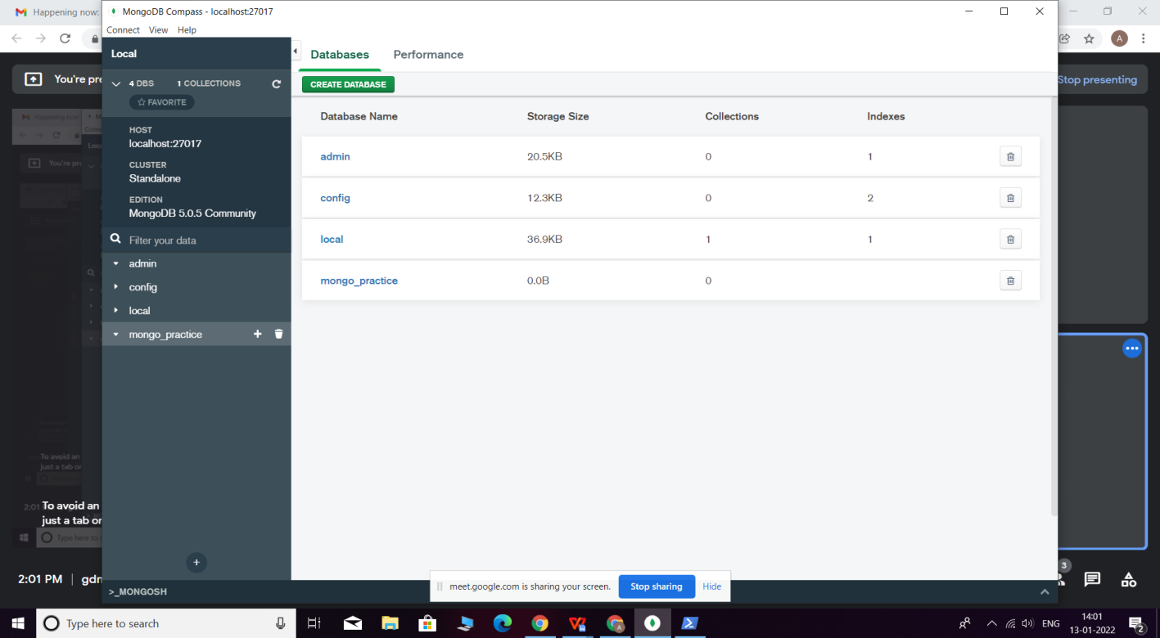

**Insert Documents**

Insert the following documents into a **movies** collection.

title : Fight Club

writer : Chuck Palahniuko

year : 1999

actors : [ Brad Pitt

Edward Norton

]

title : Pulp Fiction

writer : Quentin Tarantino

year : 1994

actors : [

John Travolta

Uma Thurman

]

title : Inglorious Basterds

writer : Quentin Tarantino

year : 2009

actors : [ Brad Pitt

Diane Kruger

Eli Roth

]

title : The Hobbit: An Unexpected Journey

writer : J.R.R. Tolkein

year : 2012

franchise : The Hobbit

title : The Hobbit: The Desolation of Smaug

writer : J.R.R. Tolkein

year : 2013

franchise : The Hobbit

title : The Hobbit: The Battle of the Five Armies

writer : J.R.R. Tolkein

year : 2012

franchise : The Hobbit

synopsis : Bilbo and Company are forced to engage in a war against an array of combatants and keep the Lonely Mountain from falling into the hands of a rising darkness.

title : Pee Wee Herman's Big Adventure

title : Avatar

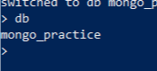

**Query / Find Documents**

query the **movies** collection to

* get all documents

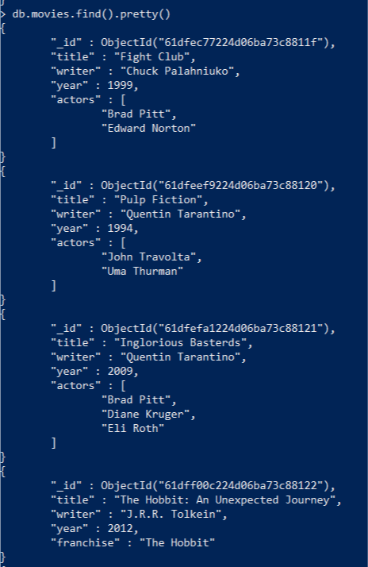

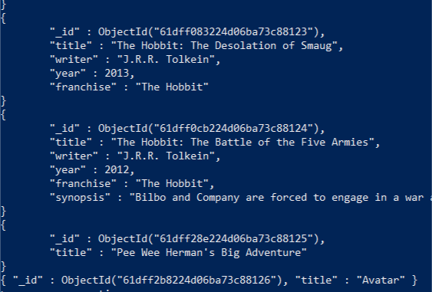

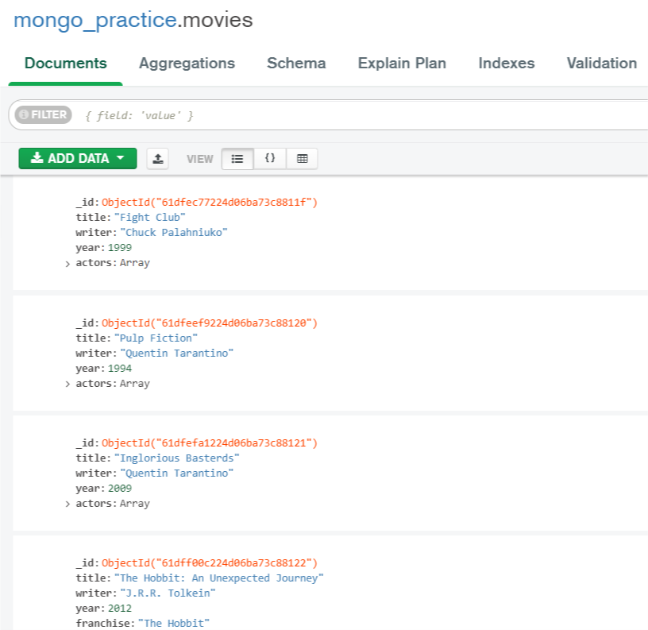

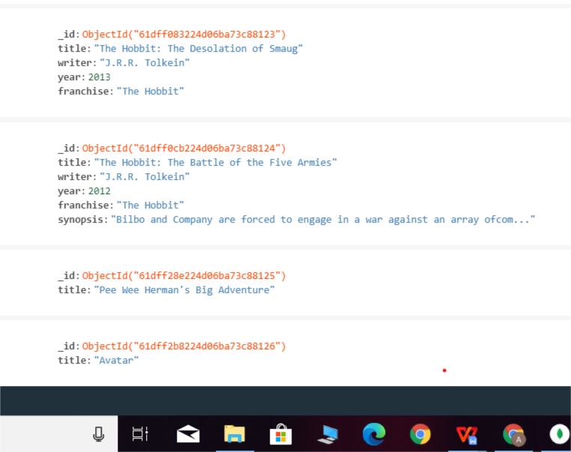

* get all documents with writer set to "Quentin Tarantino"

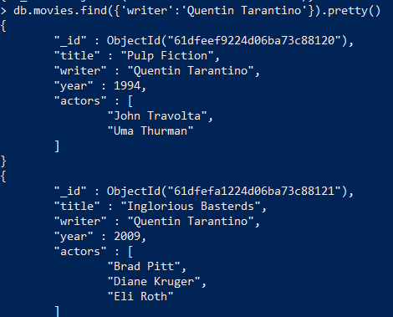

* get all documents where actors include "Brad Pitt"

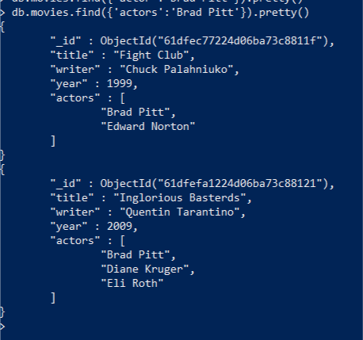

* get all documents with franchise set to "The Hobbit"

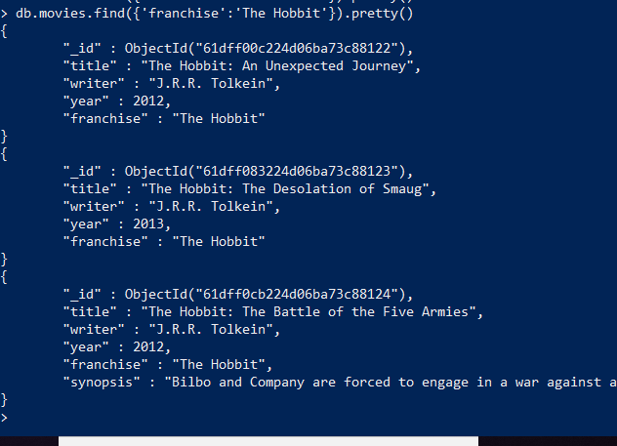

* get all movies released in the 90s

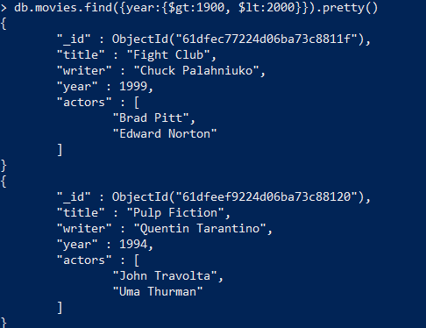

* get all movies released before the year 2000 or after 2010

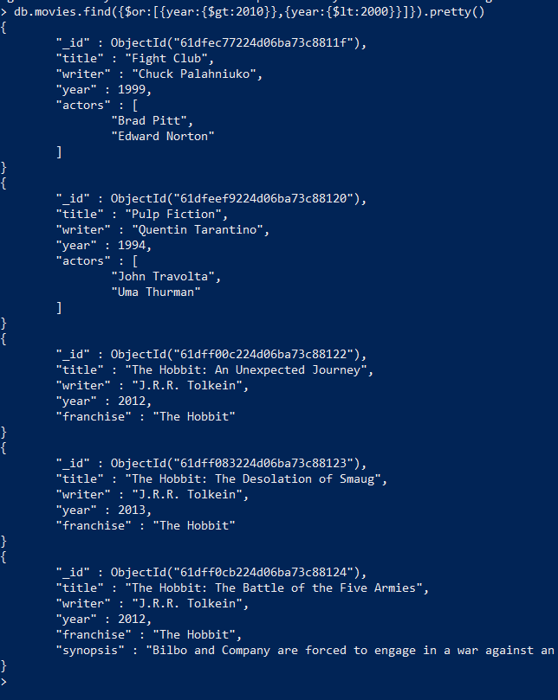

**Section-3 :- Update Documents**

1. add a synopsis to "The Hobbit: An Unexpected Journey" : "A reluctant hobbit, Bilbo Baggins, sets out to the Lonely Mountain with a spirited group of dwarves to reclaim their mountain home - and the gold within it - from the dragon Smaug."
2. add a synopsis to "The Hobbit: The Desolation of Smaug" : "The dwarves, along with Bilbo Baggins and Gandalf the Grey, continue their quest to reclaim Erebor, their homeland, from Smaug. Bilbo Baggins is in possession of a mysterious and magical ring."
3. add an actor named "Samuel L. Jackson" to the movie "Pulp Fiction"

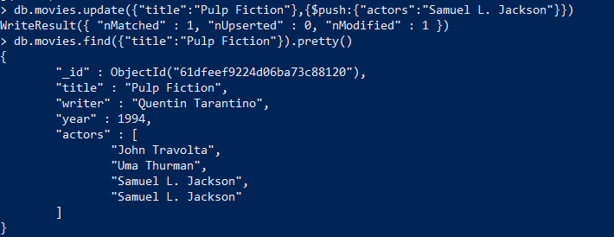

**Section-3 :- Text Search**

**Create Tect Index**

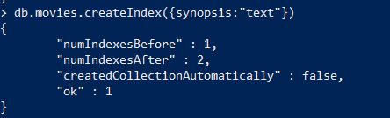

find all movies that have a synopsis that contains the word "Bilbo"

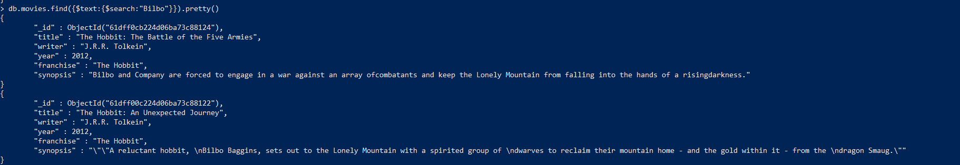

* find all movies that have a synopsis that contains the word "Gandalf"



* find all movies that have a synopsis that contains the word "Bilbo" and not the word "Gandalf"

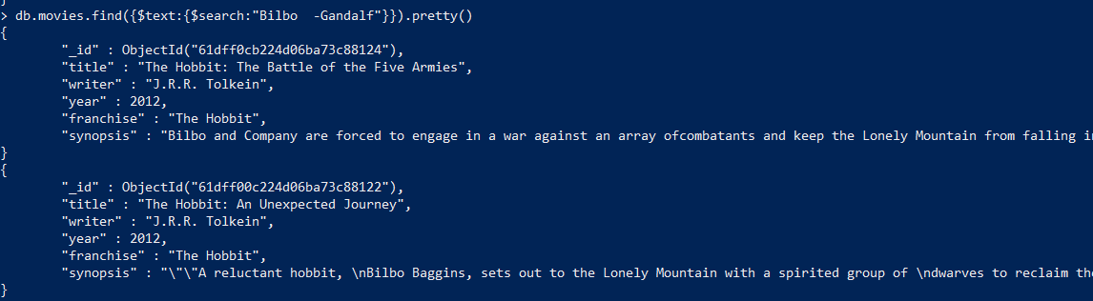

* find all movies that have a synopsis that contains the word "dwarves" or "hobbit"

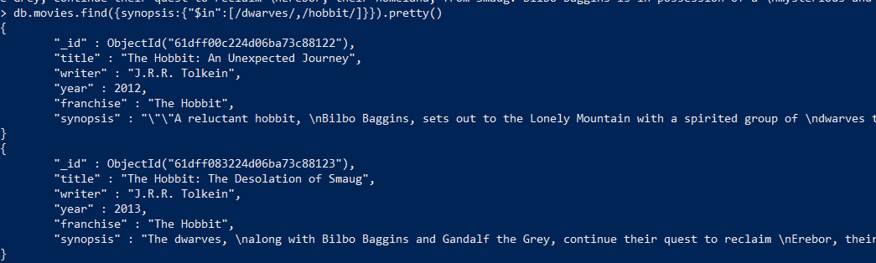

* find all movies that have a synopsis that contains the word "gold" and "dragon"

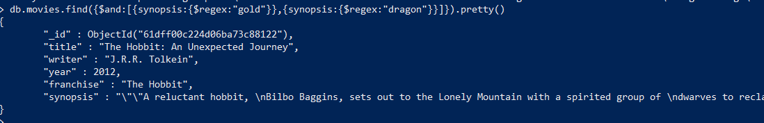

**Delete Documents**

* delete the movie "Pee Wee Herman's Big Adventure"



* delete the movie "Avatar"



**Relationships**

Insert the following documents into a **users** collection

username : GoodGuyGreg first_name : "Good Guy" last_name : "Greg" username :ScumbagSteve full_name :

first : "Scumbag"

last : "Steve"





Insert the following documents into a **posts** collection

username : GoodGuyGreg

title : Passes out at party

body : Wakes up early and cleans house

username : GoodGuyGreg

title : Steals your identity

body : Raises your credit score

username : GoodGuyGreg

title : Reports a bug in your code

body : Sends you a Pull Request

username : ScumbagSteve

title : Borrows something

body : Sells it

username : ScumbagSteve

title : Borrows everything

body : The end

username : ScumbagSteve

title : Forks your repo on github

body : Sets to private

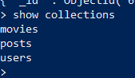

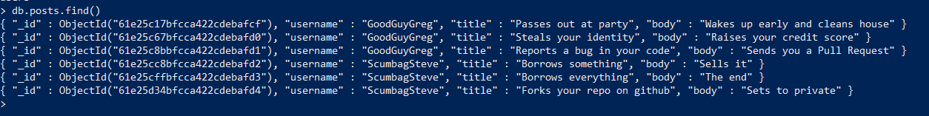

Insert the following documents into a **comments** collection

username : GoodGuyGreg

comment : Hope you got a good deal! post : [post_obj_id]

where [post_obj_id] is the ObjectId of the posts document: "Borrows something"

username : GoodGuyGreg comment : What's mine is yours! post : [post_obj_id]

where [post_obj_id] is the ObjectId of the posts document: "Borrows everything"

username : GoodGuyGreg

comment : Don't violate the licensing agreement! post : [post_obj_id]

where [post_obj_id] is the ObjectId of the posts document: "Forks your repo on github

username :ScumbagSteve comment : It still isn't clean post : [post_obj_id]

where [post_obj_id] is the ObjectId of the posts document: "Passes out at party"

username : ScumbagSteve

comment : Denied your PR cause I found a hack post : [post_obj_id]

where [post_obj_id] is the ObjectId of the posts document: "Reports a bug in your

code"

**Querying related collections**

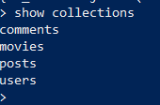

* find all users

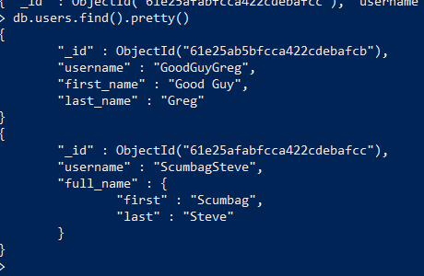

* find all posts

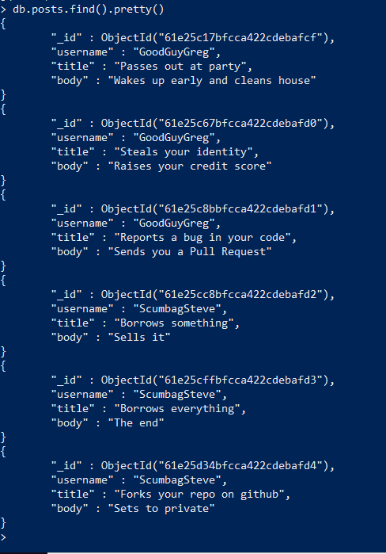

* find all posts that was authored by "GoodGuyGreg"

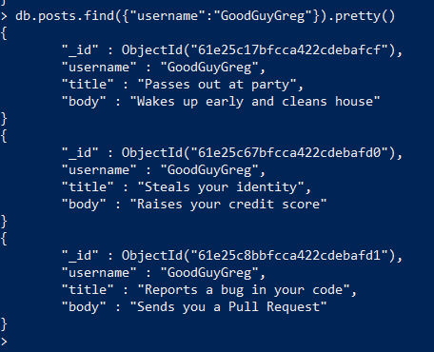

* find all posts that was authored by "ScumbagSteve"

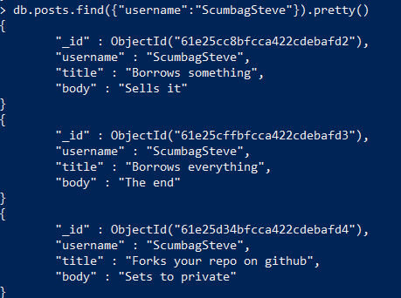

* find all comments

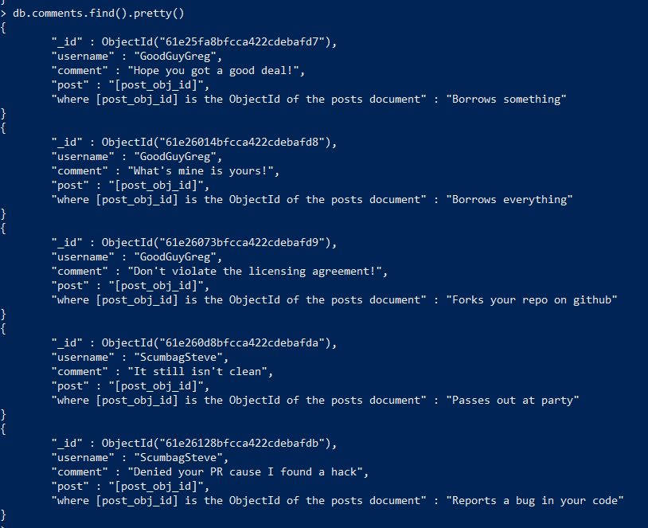

* find all comments that was authored by "GoodGuyGreg"

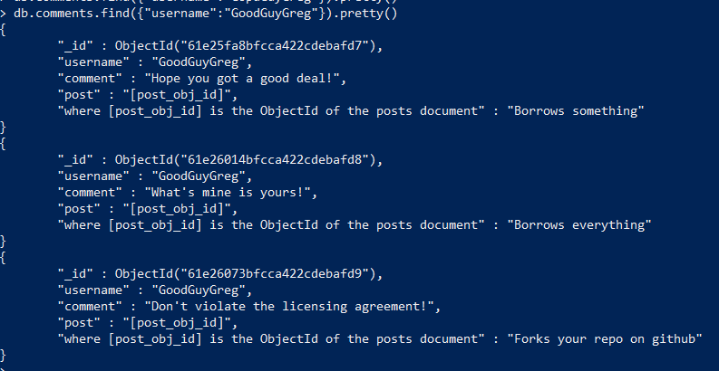

* find all comments that was authored by "ScumbagSteve"

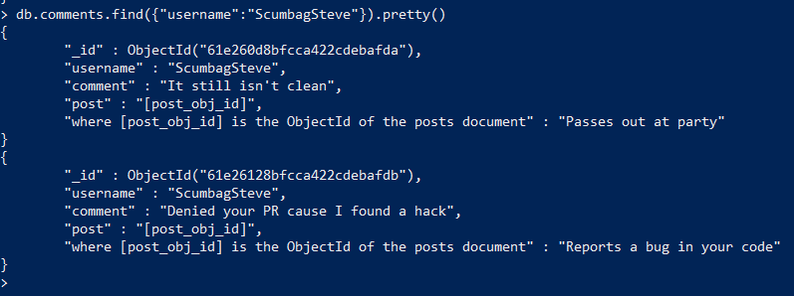

* find all comments belonging to the post "Reports a bug in your code"

References: <https://docs.mongodb.com/manual/reference/method/db.collection.find/>